(Approx. 364 words)

Let’s be safe out there
By Matt Batt, President, The Computer Club, FL
https://www.scccomputerclub.org
mbatt453 (at) gmail.com

We’ve all heard about all the hackers and the data breaches that have happened to so many on-line sites. We shudder when we hear the names of the sites. But, what we don’t know is if our own email address and passwords were actually compromised.

There is a website, haveIbeenpwned.com, that has collected the information published by hacked companies when they disclose those email addresses that have been compromised. This website has been operational for five years, gets about 60,000 visitors a day and seems to be a safe site to use. Its purpose is to provide the general public a convenient way to see if their private information has been leaked or compromised.

When you bring up the haveibeenpwned.com site, you are greeted with a field to type in your email address and instructions to “Check if you have an account that has been compromised in a data breach.” It is safe to type in your email address. You aren’t disclosing any information that isn’t all over the web already.

After you type in your email address and click on “pwned?”, you will either get Oh ho – pwned! Or Good news – no pwnage found! If you have been part of a breach, you will see a description of each breach along with the date of the breach and what was compromised. In my case, my email address and password were compromised in the Adobe breach of 2013 and in the Zomato breach in May of 2017. It suddenly seemed like a really good idea to change my password.

You can select an option for the site to notify you if your email address shows up on any new list of breaches email addresses. When you select “notify Me” from the page menu, you’ll get to prove you are not a robot and you’ll be sent a verification to confirm that you are real.

If you discover that you have been breached, do change your password on that email account. Also9, if you use that same password on other accounts, change them also.

“Let’s be careful out there!”

How to know if you’ve been hacked
Worried you've been hacked? Use these sites to find out and protect yourself
By Tyler Lacoma, Digital Trends — Posted on February 2, 2019 4:25AM PST
The best way is to find out if your security has been compromised as soon as possible so you can take personal action, which is where data breach detection websites come into play. These sites allow you to securely search through the latest hacked data to see if any of your sensitive information is at risk. We’ve rounded up four of the best for you to use based on your security needs, so let’s dive in.

HAVE I BEEN PWNED?
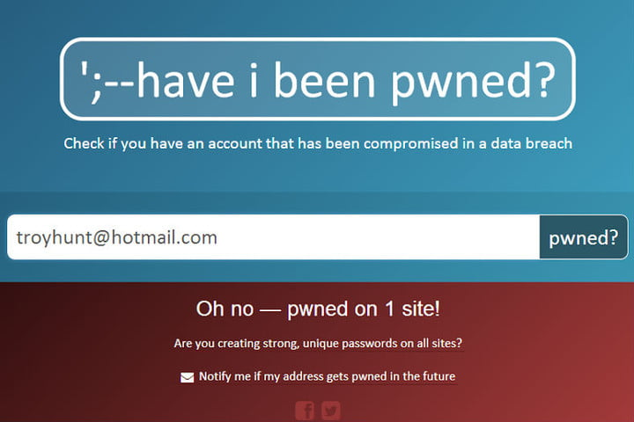
Have I Been Pwned is one of the oldest, most popular, and best sites in the game. The site works hard to track down breaches, verify them as legitimate, and nab data so you can check it out. You can read more about site runner Troy Hunt and his thoughts on the business here.
Once you log onto the site, you’ll be greeted with a basic search bar and a list of the latest and largest breaches. Just type in your email or username, and the site will search the breached data and showcase any red flags. You can also search more sensitive breaches, but only if you take the time to verify your email address. There’s also an option to deep link straight to a particular account, so you can instantly bring up results for one particular email address if you plan on doing a lot of repeated searches.
It’s a simple tool that still allows for some customization as needed. Moreover, it’s obvious that Hunt really cares about this sort of white hat work, as well as educating users on the dangers of data breaches

